# Definition of the context and of the scope

The task of the ultrasonic sonotrode is to transfer the mechanical vibration energy to the welding part and assure a constant high welding quality. This part has many vibrating modes: each mode has a eigenfrequency and an eigenshape. The first longitudinal mode in particular is used to drive the vibration and has the following requirements:

* its eigenfrequency should be around the driving frequency
* the displacement of the eigenshape at the welding surface (output surface) should be as uniform as possible
* it should be isolated from other modes

The modal properties of the sonotrode are simulated with the software Ansys. They depend on the material properties (supposed constant for that study) and the geometry. The geometry is usually tuned by the engineer in an iterative way and simulated until the requirements of the modal properties are filled.

The geometry of the sonotrode is described for this project between 2 and 23 parameters, depending on the sonotrode type and complexity. The data were generated from the simulation results of many hundreds of design points, classified in three families:

* in the design family 01, the geometry of a blade sonotrode is changed according to 2 parameters only (slot position and slot length, see next schema)
* in the design family 02, the same blade sonotrode is described geometrically by 5 parameters instead of 2 parameters

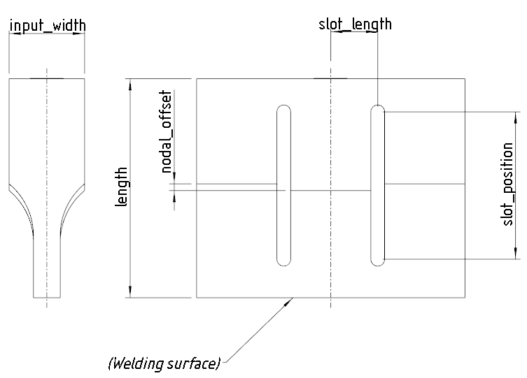

* the block sonotrode of the design family 03 is parametrized by 23 parameters

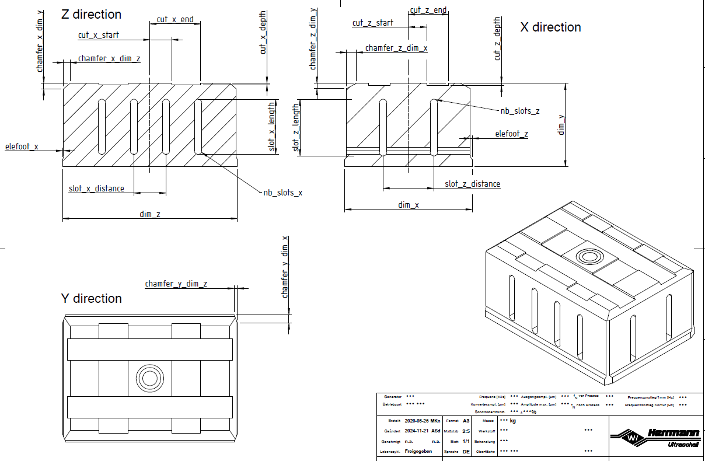

The longitudinal mode is identified in the Ansys post-script with the MAC (Modal Assurance Criterion), which compares the eigenshapes with a reference vector.

The objective of the project is predict the FEM results (eigenfrequencies and eigenshapes) with Machine Learning models. These predictions should permit to:

* calculate the eigenshapes of each mode
* estimate the frequencies of each mode
* automatically determine the number of the first longitudinal mode (optional requirement)

A greater precision is required particularly in the vicinity of the first longitudinal mode (direct neighbor modes, for example the 5 modes below and 5 modes above).

# Discovering of the dataset and its structure

(Data Audit)

For the creation of the data samples, many hundred of design points were randomly generated in arbitrarly defined ranges and calculated in FEM. The design points are listed in Excel for each family and exported as CSV files

**design-points-01.csv**

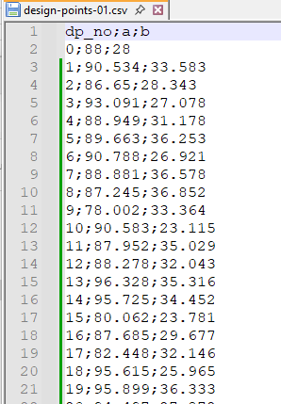



**design-points-02.csv**

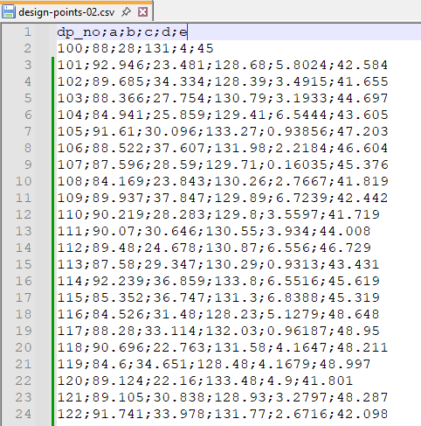



**design-points-03.csv**

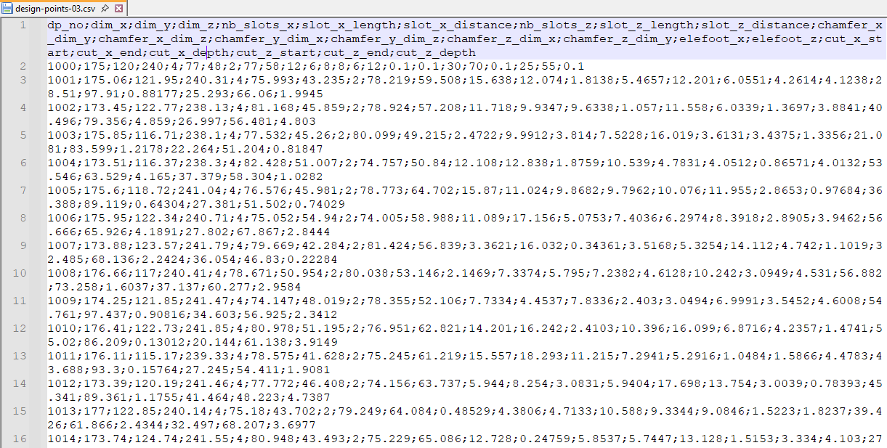



The FEM results are exported for each design family in one main file and 3 subdirectories:



* the „main file“ **mode-ident-full-0x.dat** contains the overview of the design point results, one line per design point

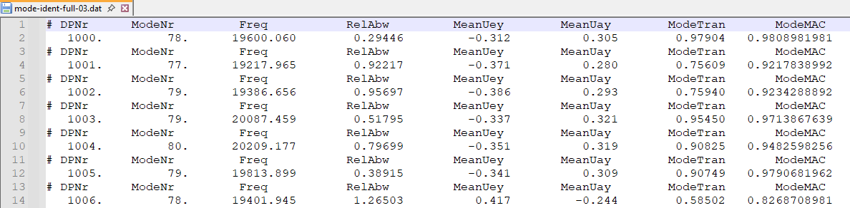

The columns names given as output from Ansys should be renamed for better understanding and displayed only once. This contains the mode number of the identified longitudinal mode in Ansys. The other features are actually redundant, since they can be picked from the „mode files“.



* for each design point, 3 different files are written in the corresponding subdirectories:
  + the „mode files“ tbl-modes-(dp).dat contain the list of the first calculated modes

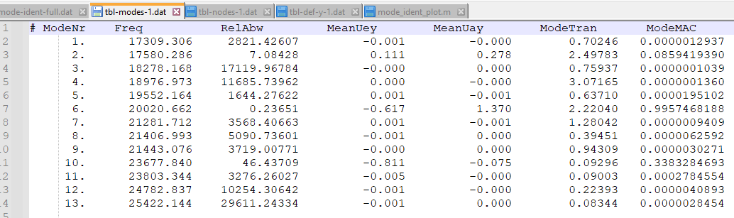



* + the „node files“ tbl-nodes-(dp).dat contain the nodes of the output surface only, with coordinates

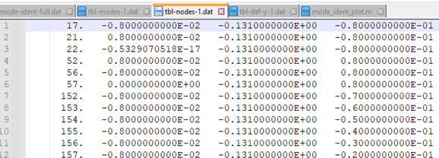



* + the „deformation files“ tbl-def-(dp).dat contain the displacement of the nodes located on the output surface. The displacement are given for each mode and in the longitudinal direction only (Y-direction)

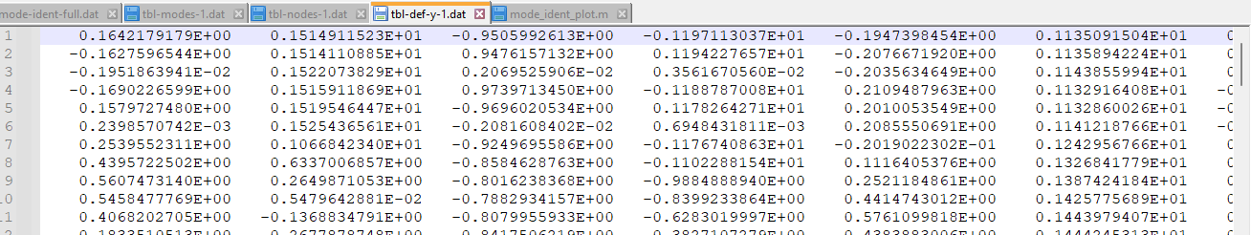



# Data consolidation

* Rassembler toutes les données d'un seul coup pour éviter de revenir aux fichiers bruts:

* Extraire les paramètres géométriques des fichiers CSV

* Collecter les résultats de simulation FEM (fréquences et déplacements)

* Créer un dictionnaire ou DataFrame centralisé avec tous les design points

All the data are collected in the dictionary all_data to avoid to deal with raw data again.



* The first key is the design family
* The key „parameters“ contains the list of design points with geometrical parameters. The list of design points is read from „design-points-xx.csv“ and is different for each family
* The key „identification“ contains the number of the longitudinal mode from „mode-ident-full-xx.csv“
* The key „design_data“ contains the data of all design points: modes, nodes and deformations

DataFrames for the design family „02“

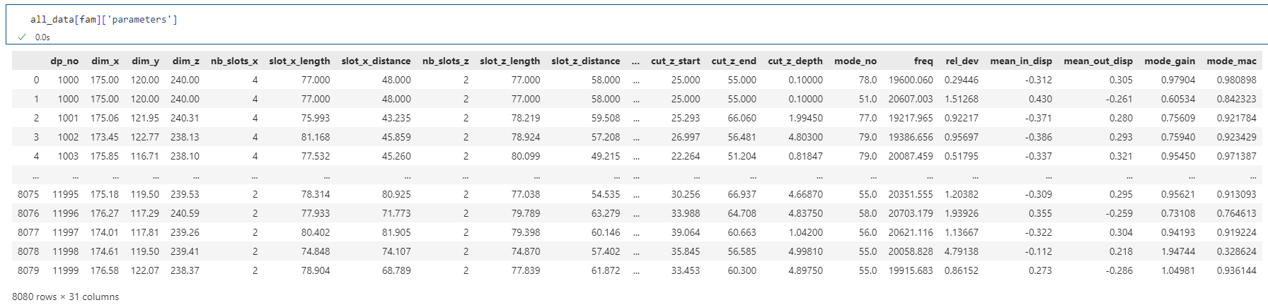

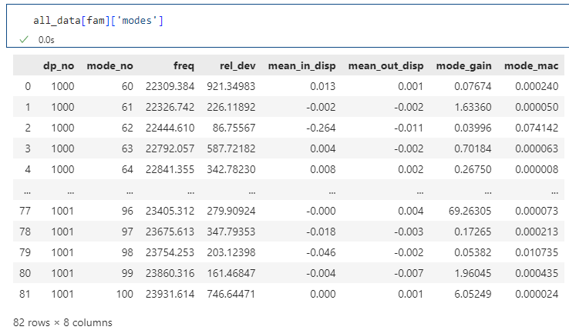

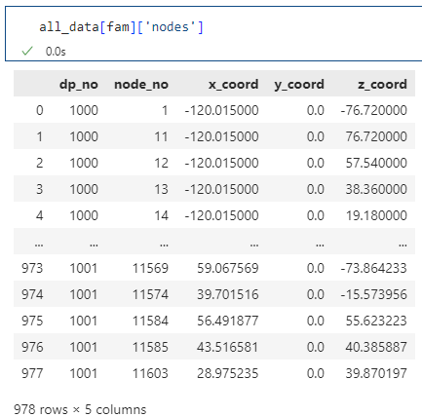

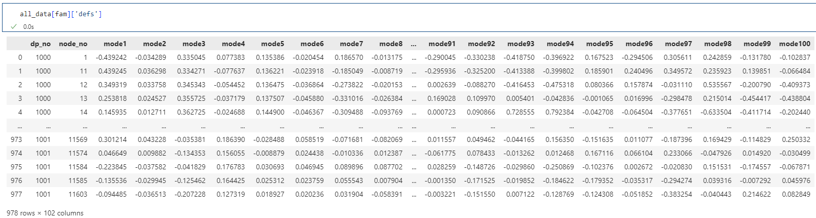

# Data exploration

Distribution of the geometrical parameters

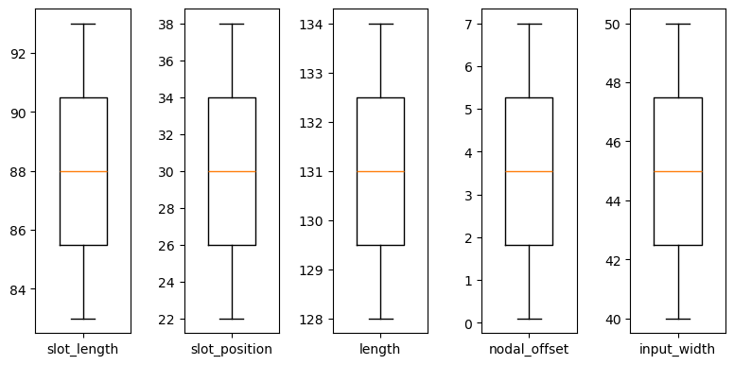 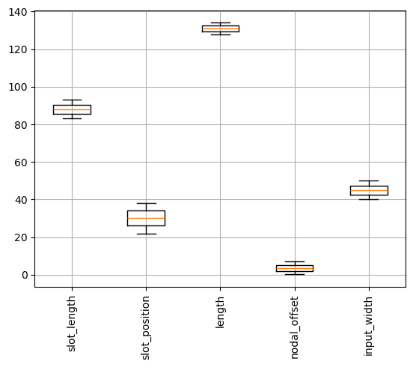

Exploration of the correlation between the parameters

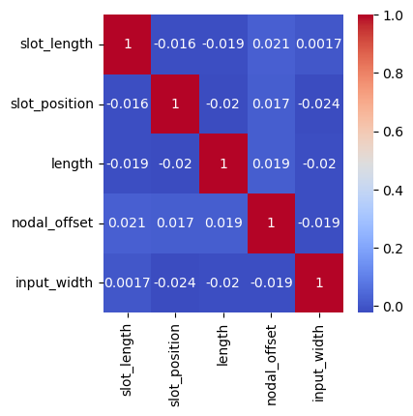

* The design points were independantly generated with a normal distribution

Visualize the range of the geometrical parameters

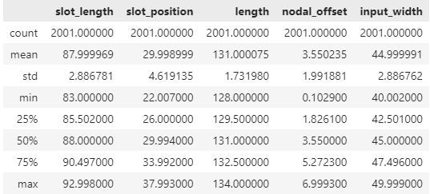

# Graphical representations (at least 5)

Uniformity of the displacement of the output surface for some longitudinal modes

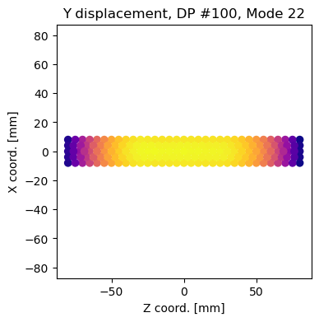 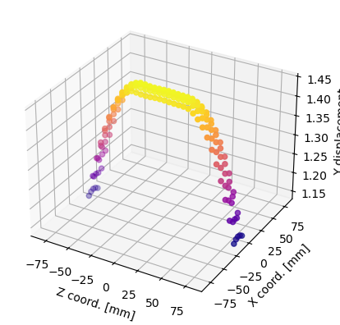

Visualization of the deformation shape for some modes (3D)

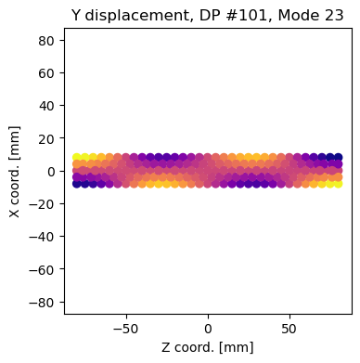 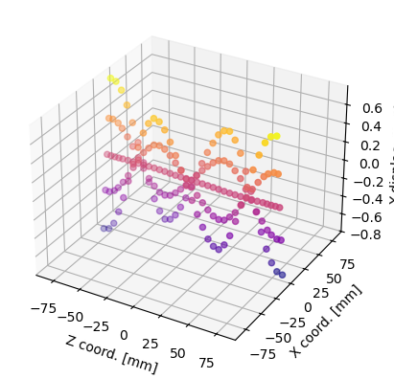

Distribution of the number of the longitudinal mode

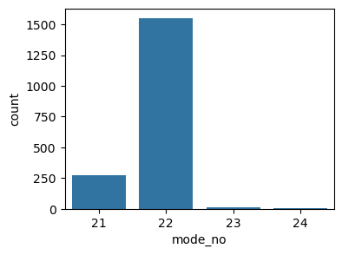 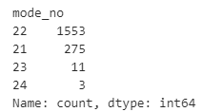

Distribution of the longitudinal frequencies around the nominal frequency

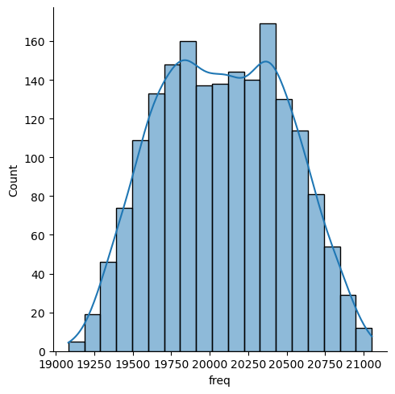

Sensivity of the geometrical parameters in the longitudinal frequency

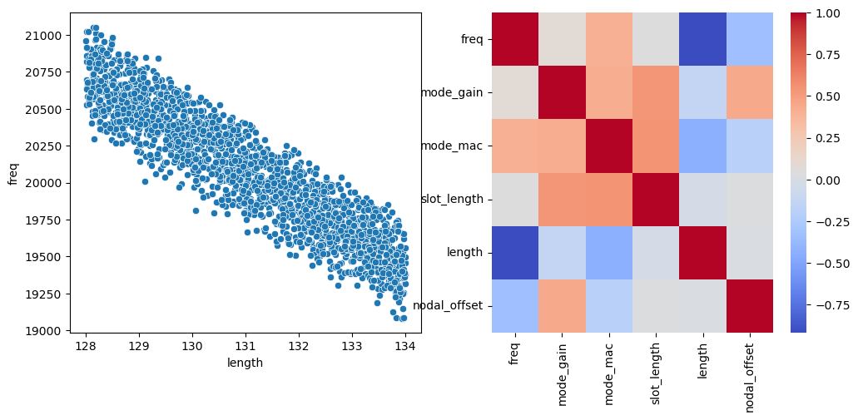 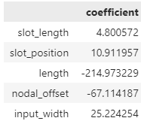

Sensitivity of the geometrical parameters in all frequencies

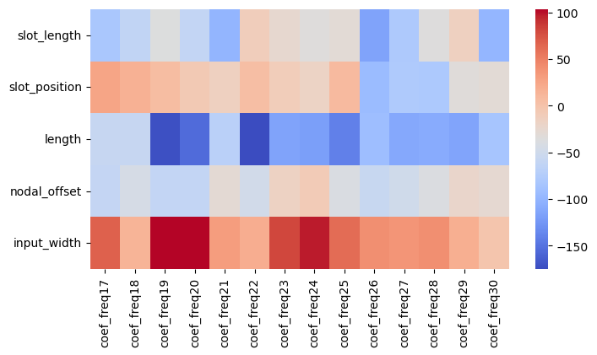

# Identification of the longitudinal mode

Elaborate a method to identify manually the first longitudinal mode

Validate this method for many design points

Recalculate the MAC value for each mode and compare with the values retrieved from Ansys